# **Chapter 9 APPENDIX**

## 9.1 Quick Start Guide

The developed pharmacy e-commerce app is a web-based application that is aimed at providing a new means of running pharmaceutical store and the interaction between users and professional pharmacist for consultations.

**Application Requirements**

The minimum requirements for running the apps are:

1. A computer or mobile phone device.
2. The mobile phone needs to have a functioning and effective internet connection.
3. Installation of a web browser application.
4. After the installation user can then visit the website @ https://pharmacy-client.vercel.app to register their information on the app by providing their name, email and password. After successful registration users can then login with their registered email and password after which they can then access the resources available in the app.
5. User can also use the search tool resource to search through all the medicine in stock.
6. Users can always log out of the app and login at any time and still have their setting all kept intact.

9.2 Test Case Result

Black box testing was carried on the user end of this software while unit testing and system design test is carried on the programming flow the new app.

Below is the result of the test:

|  |  |  |  |
| --- | --- | --- | --- |
| **SNo** | **Test Item** | **Test Method** | **Test Result** |
| 1 | Access Control Ability | Unauthorized user access to the system. | Interception Successful |
| Unauthorized access to other user information. |
| Unauthorized access to application data. |
| 2 | Functional logic requirement | User Registration | Test results are according with the set requirements. |
| User Login |
| Adding items to Cart |
| Checking out cart |
| Adding item to Wishlist |
| Users and user role Management |
| Managing user Information (Updating profile) |
| Navigating between the apps |
| Managing the inventory (adding or updating products) |
| Managing previous orders |
| Chatting Live with consultants |
| Login out |
| 3 | Non-Functional logic requirement | User Experience | Test results are according with the set requirements. |
| Content Navigation |
| Enforcement of login before accessing the app protected resource |
| User input validation |
| Loading time |

## 

## Project Meeting Logs

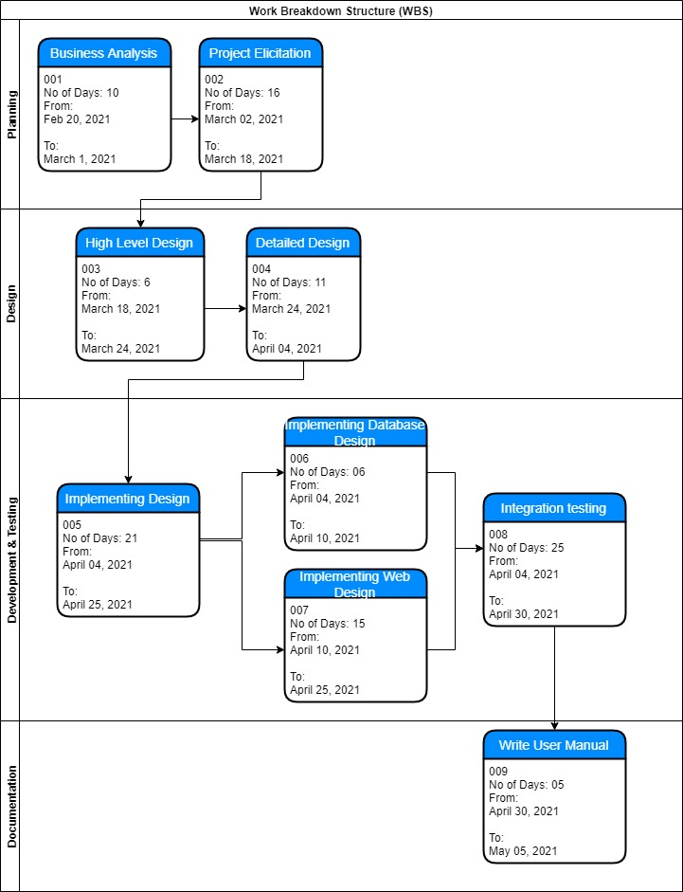

9.4 Timeline (Gantt chart)

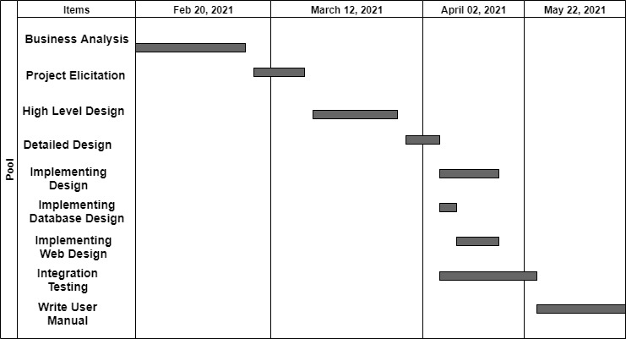

References

1. fouda.com. (2013). fouda. Retrieved October 25, 2020, from <http://www.fouda.com/>
2. http://adamapharmacy.com/. (2016). adama pharmacy. Retrieved October 24, 2016, from <http://adamapharmacy.com/en/?sl=ar>
3. http://dowa.co/. (2016). Dowa Kuwait Online Pharmacy. Retrieved October 30, 2016, from <http://dowa.co/>
4. http://dowa.co/t-aboutus.aspx. (2016). About us. Retrieved November 17, 2016, from <http://dowa.co/t-aboutus.aspx>.
5. Peersman, G. (2014). Overview: Data Collection and Analysis Methods in Impact Evaluation, Methodological Briefs: Impact Evaluation 10, UNICEF Office of Research, Florence.
6. Martin, J. (1991). Rapid Application Development. Macmillan